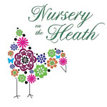  Nursery on the Heath  Hatfield Heath  Hertfordshire CM22 7EB  Tel. 01279 730 331  enquiries@nurseryontheheath.co.uk  www.nurseryontheheath.co.uk  “At Nursery on the Heath  we strongly promote mutual respect,  inclusion and fairness for  every child and their family  who walk through our door.” | Summer Term Newsletter  May 2019
13th – 17th May  Peppa Pig’s Muddy Puddle Activities for Save The Children  Monday 27th May  Spring Bank Holiday  Saturday 8th June  Queen’s birthday  Sunday 16th June  Father’s Day  Saturday 20th July  50th anniversary of landing on the moon  Thursday 15th August  Graduation Day  Monday 26th August  Summer Bank Holiday  Saturday 31st August  NOTH Stonehall Fest  for our Pre-school leavers | A very BIG welcome to all our new babies, children, mummies and daddies who have recently join Nursery on the Heath (a.k.a. NOTH). We look forward to getting to know you and are honoured to share your child’s learning journey during these important early years.  This Summer Term is already in full swing with Peppa Pig activities in abundance this week to raise money for Save The Children, this term’s fundraising event – please pop your donations in the box. The rest of the term will then take a new direction with the warmer months ahead including the 50th anniversary of landing on the moon!  If you are going away, we’d love to hear about your travels. This will help the staff keep the children’s learning in context so do share as much as possible about your destination, mode of transport, the weather, language, food, architecture, history and points of interest. Photos are welcome and make a valued contribution to the children’s learning journals.  An additional focus of learning for many children in The Barn this term is getting ready for the transition to school – a significant milestone of childhood. A time that brings not only opportunities but also challenges as they will soon be navigating new and larger surroundings, peer groups and behaviourial, social and physical demands and expectations that are different from those at home and at NOTH.

Help us clean up!  Upwards of 9 million tons of plastic enters the world’s oceans each year and every day tons of rubbish gets washed ashore.  So if you are heading to the coast this summer help the environment, lead by example and inpsire others too by collecting rubbish from our shores and dispose of waste appropriately.  Not sure what to do with your non-recylable waste? Make an EckoBrick! An EcoBrick is a plastic bottle packed tightly with clean and dry, non-biodegradable waste. These bottles can then be used as building materials to create insulative structures and colourful furniture. Here’s how:  Collect your clean & dry household waste  - Twist your waste & insert it into a plastic bottle  - Compress it as tightly as you can with a stick.  - Make sure your bottle is unsquishable  - If you can squeeze it by more than 10% in one hand you should add more waste  - No longer squishable? It’s done!  Would like more info? Sign up to the EcoBricks UK FaceBook page. |  | 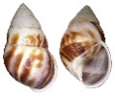  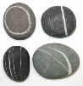  We Need You!  We would like to increase our supply of loose parts for the children to play with – shells, stones, seaweed, logs, sticks etc. Loose parts provide open ended learning and bucket loads of curiosity and creativity. Here’s how you can help: if you are taking a beach holiday this year we would love your little one to collect a small shell or pebble to bring back to Nursery to show their friends. Baskets will be on display in the foyer to entice collections, which are a great way to promote personal responsibility, maths and social skills.
Father’s Day Celebrations  Our babies and children are busy preparing for this special day next month so please save the date!  Invitations with details to follow:  Friday 14th June  Father’s Fun Day – The Tweenie Room  Monday 17th June  Daddy’s Day - The Baby Room  Tuesday 18th June  Sport’s Day - The Barn |  | Happy Birthday!  Our Apprentices Loren and Sophie both turn 18 this month – happy birthday girls!  Hope your days are filled with lots of love, fun, laughter, cake, bubbles and balloons!  Sophie – Sunday 19th May  Loren – Thursday 30th May  Going to the chapel …..  Wishing parents Claire Stephens & Jack Bryson the very best for their special day. Claire and Jack will be walking down the aisle on Saturday 25th May. Have a fantastic day!
Employee of the Month  Every other month we ask parent, carers and staff to vote for our Employee of the Month. This is to acknowledge their hard work as well as the love and care invested in every child.  If you would like to recommend someone, please fill in a voting form or send the office an email.  April’s Employee of the Month was rewarded to Keeley Newman, who was recognised for:  going the extra mile  showing genuine care  being friendly and approachable  taking the time to listen  showing unwavering support  being attentive to children and parents  always smiling  Who gets your vote? | Staff News  The Summer term brings some changes to our teams:  We would like to say goodbye to Emma, who is leaving us after her honeymoon to look after and care for Children with Special Educational Needs. We also say farewell to Leanne, who has decided to take a term-time Nursery position, so she can spend more time with her family. Good Luck Emma and Leanne!  As Marisa’s maternity leave begins, we eagerly await the news of an addition to the NOTH family! Whilst Sian’s has come to an end, she has decided not to return to NOTH and is enjoying the special moments being mummy to little Jacob. Good Luck Marisa and Sian!  Where one door closes another opens, and we are delighted to announce some new team members to the Nursery:  Sophie Jones – Sophie has been appointed as an Apprentice and is working across all three rooms on Wednesdays, Thursdays and Fridays.  Stephanie Bandey – Stephanie has been appointed as a qualified Level 3 Key Person in The Tweenie Room. Stephanie joins us from a Montessori nursery in Chelmsford.  Katie Chalk – Katie has been appointed as a Key Person in The Baby Room. Katie is a qualified Level 2 practitioner with two years’ experience and a passion for working with babies.
Inspiring Excellence in Paediatric First Aid  We are delighted to announce that all 26 staff are trained in Paediatric First Aid. This is an exceptional achievement for the Nursery that demonstrates the children’s safety is at the forefront of our practice, as well as a great accolade to each individual team member.  At the end of the Summer term we will begin our Millie’s Mark journey; a 6-month process where the Nursery will work in partnership with a Millie’s Mark mentor to:  - check our processes and procedures are up to the standard required through a nursery audit  - carry out a staff confidence audit  - complete a staff training matrix  - review our floor plans  A full online assessment and additional checks with quality control spot checks will also take place to ensure we meet the criteria for Millie’s Mark. We will keep you informed as developments occur. If you would like any more information, please contact the office. | The 13 minutes that defined a century …  We will be joining the many others around the world this July to celebrate the 50th anniversary of the moon landing, a moment in time that defined history. This amazing feat will provide many wonderful learning opportunities and experiences for the children. What will you be doing?  Suggested websites for more info:  www.moonlanding50.org  www.nasa.gov/specials/apollo50th  Why not check out the BBC World Service  Special Podcast Series?
It’s twins!  Huge congratulations to our Tweenie parents Kirsty and Scott who are now proud parents to two baby boys, Freddie and Ollie. Big sister Bella is proud as punch! We can’t wait to meet them ….. |  | What to pack …  Summer may be on it’s way, but with the everchanging British weather please ensure that your child arrives at Nursery prepared for all weathers including a sun hat, a waterproof jacket and wellies. A water bottle is a must and please remember to label everything! If you wish for your child to use their own suncream,  please remember to notify the office.
Summer Menu  Jill is been busy trialling a new 3 week menu and as usual there have been lots of empty plates.  You can find a copy of this, together with lots of other NOTH information, on our website. www.nurseryontheheath.co.uk | Slippers!  To support our ‘home from home’ ethos we like the children to wear slippers when inside for maximum comfort and to keep little toes warm and protected. Please bring in a pair for your child as soon as you have the opportunity.  Thank You.
Forest School  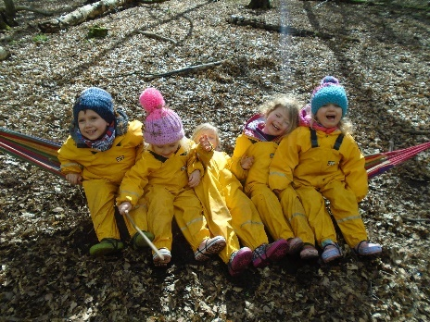  This term Forest School is taking place on Fridays and will include visits to Birchanger Woods and the Paddock:  Birchanger Woods  17th May, 7th June, 19th July, 26th July  The Paddock  10th May, 31st May, 21st June, 5th July,  2nd August (Camp Fire and Tools Day),  Please ensure your child is adequately prepared for a day in the Forest or at the Paddock. In addition to the regular kit list, we would be grateful if you would pack a bottle of Insect Repellent for the Summer Term. Environmentally friendly brands are recommended.  If you require a kit list; need any further  FS information or have any questions,  please speak to Elaine or send an email to: enquiriesnothforestschool@yahoo.com | Our Gardens  The Flower Garden  Improvements have been made to our Flower Garden to enrich the children’s learning. With flowers and herbs to look after and care for, as well as an array of loose parts to explore, the children’s play is open-ended and flourishing with creativity. This space will be an evolving project, led by the children, the seasons and the available resources.  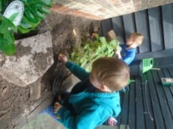  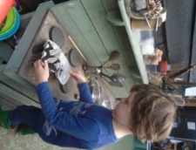  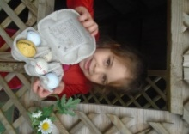  Yet to visit? Please simply ask a member of staff for a peak –  we hope you agree, it’s simply wonderful!  The Front Gardens  This term will see improvements to our front gardens and forecourt. The Barn children have already placed their vote for the new colour of the shed – the winning colour: seagrass. The next stage is to get painting and install some new shelves, ready to be filled with new toys and more loose parts. Here’s how you can help: if you are clearing out your kitchen cupboards, shed or garage keep us in mind as we are on the hunt for:  Pots, saucepans, wooden spoons, silver/wicker serving items and baskets, rolling pins and chopping boards.  Watering cans, jugs, colanders, strainers, plumbing parts  Scaffolding planks, cable reels, tyres  ‘One man’s rubbish, is a”NOTH”er childs’ treasure’
Meet the Team
 | 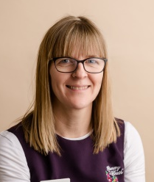
 | Sally Hough  Nursery Manager | Julie Cross  Deputy Nursery Manager | Marisa Pikett  Third in Charge | Jill Brownlie  Cook
The Baby Room
 | Charlotte Trevitt  Trainee Room Leader Lv 3 | Sue Sugar  Key Person Lv 2 | Karen Roethenbaugh  Key Person Lv 3 | Katie Chalk  Key Person Lv 2
The Tweenie Room
 | Lucy Pryor  Co Room Leader Lv 3 | Terri McWilliam  Co Room Leader Lv 3 | Jenny Chamberlain  Key Person Wt Lv 3 | Stephanie Bandey  Key Person Lv 3
TheBarn
 | Kiera Jackson  Room Leader Lv 3 | Holly Monaghan  Key Person Lv 3 | Keeley Newman  Key Person W/t Lv 3 | Elaine Taylor-Mayes  Forest School Leader
Support Staff
 | Carol Speed  EY Practitioner  The Barn | Marta Folgori Ellie Collier EY Practitioners  Tweenie Room | Katie MacDonald  EY Practitioner | Loren Bagley Sophie Jones  Apprentice Apprentice
Support Staff |  | 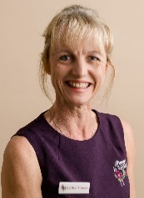
 | Ann Jackson  Bank Staff Member | Deborah Cooper  Bank Staff Member | Emily Price  Bank Staff Member | Karen Pollack  Bank Staff Member

